Saduq Rahman

March 7, 2021

Foundations of Programming, Python

Assignment 8

**CDIventory Python OOP**

**Introduction**

In assignment 7 we begin to utilize Object Oriented Programing (i.e. OOP) which utilizes classes as a blueprint that defines a collection of objects. It is a logical entity that has some specific attributes and methods. The variables and the methods of an object is a group of interrelated variables and functions, these variables are often referred to as properties of the object and function are referred to as the behavior of the objects. These objects provide a better and cleaner way to divide and self-contained the objects or create several mini programs. Every Individual object represents a different part of the application having its own logic and data to communicate within themselves.

**Drafting the Code**.

I used the program spyder to write and test the code being written, my first step was going thru the labs by the teacher in module 8 and (Dawson, 2010) . To try and grasp the idea of how the OOP works in addition I spent allot of time researching what an __init__ and how it works and the concept of using self as the call out function for the __init__ function. Ran into some issues with using the try and except and incorporating them within the setters, since I wasn’t have any success with that went ahead put them in the particular functions that I felt they where needed. Made sure to correct some of the issues from the previous week especially when using the error handling was crashing if the user was would put in a string instead of an integer. The other issue I had was with the append overwriting every time I add a new item to the CDIventory after pulling out some hair I ended up fixing the problem, but impacted the print formatting which is something I am still trying to figure out maybe you can point me in the right direction after you review the code.

As you will see within the figures depicted below:

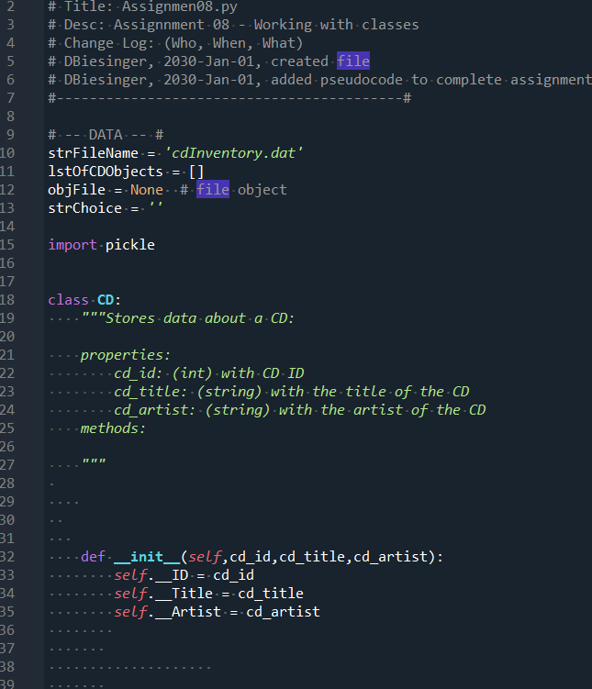

Figure I

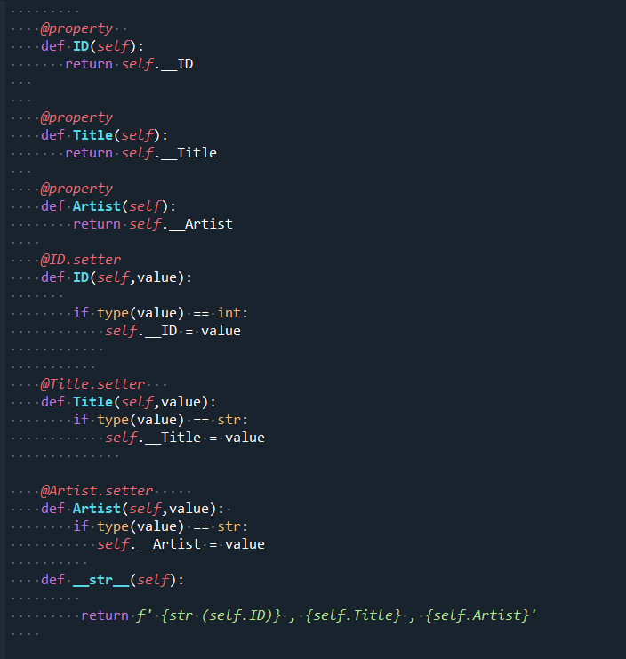

Figure II

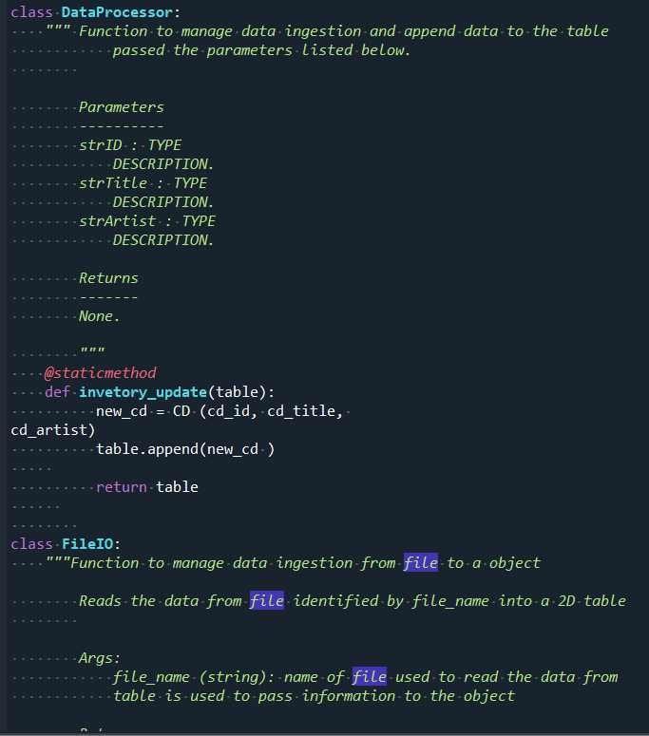

Figure III

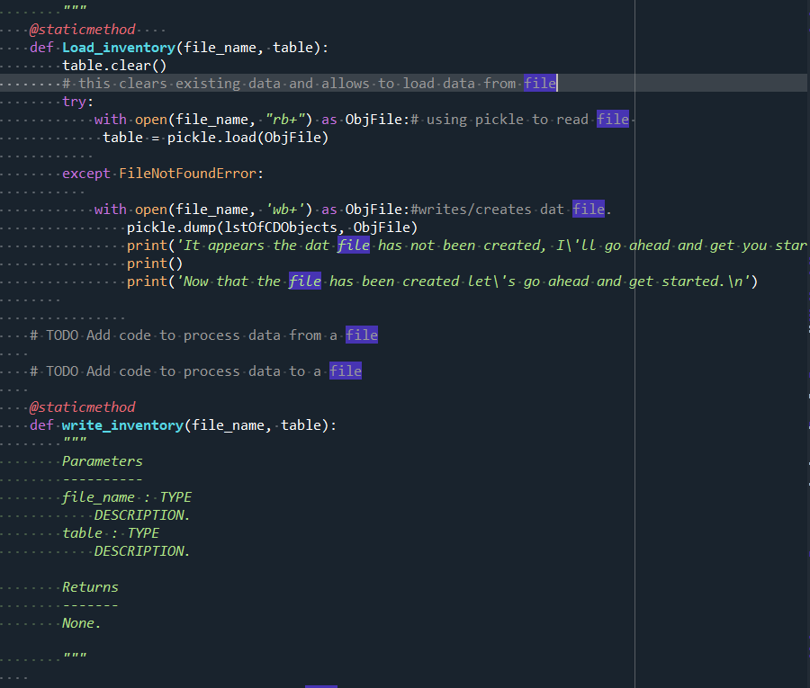

Figure IIII

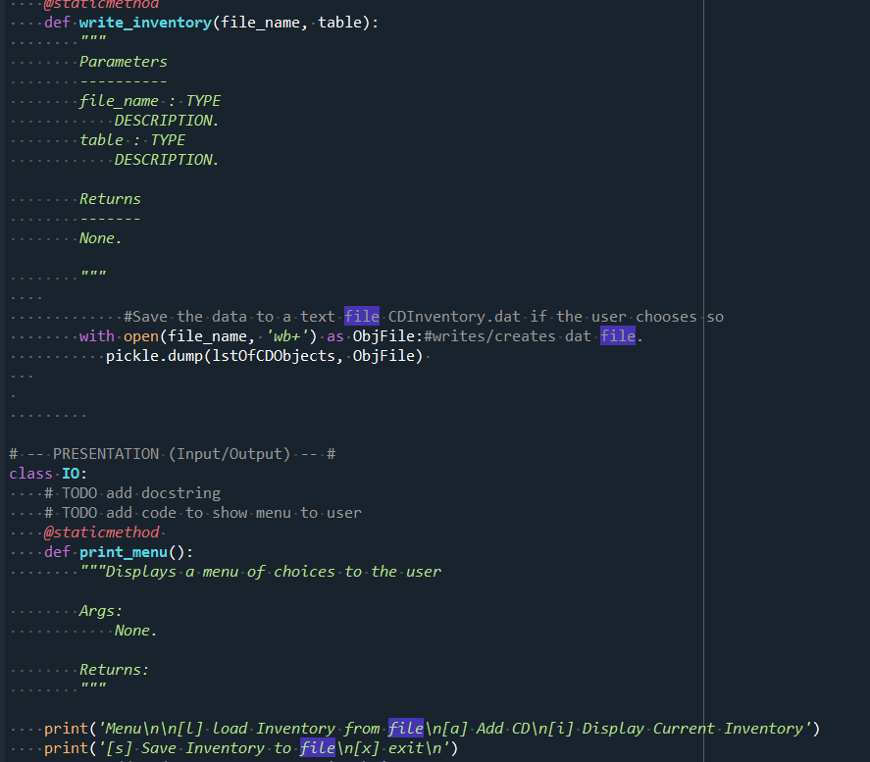

Figure V

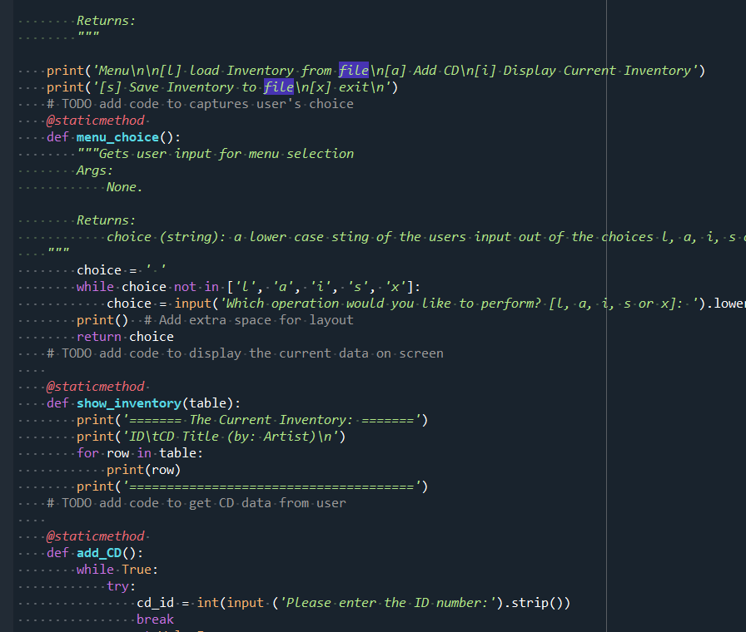

Figure IV

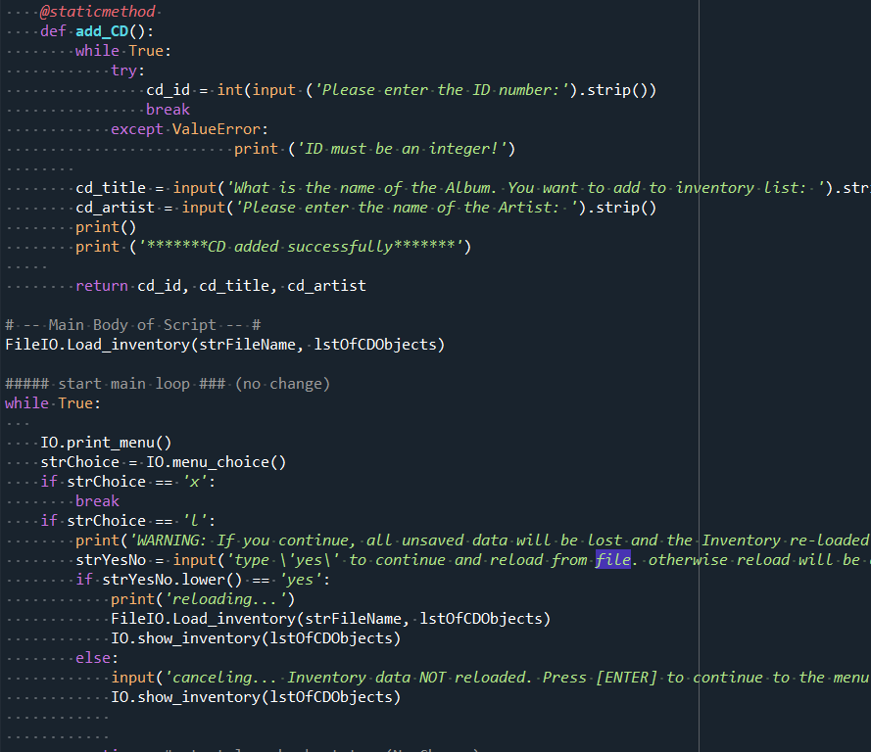

Figure IIV

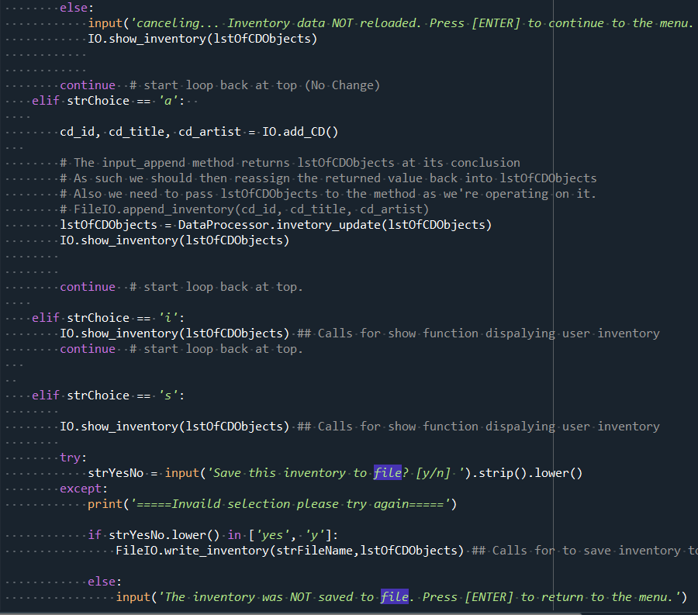

Figure IIV

**Operations:**

The output in the program displays the current inventory for the user within the program.

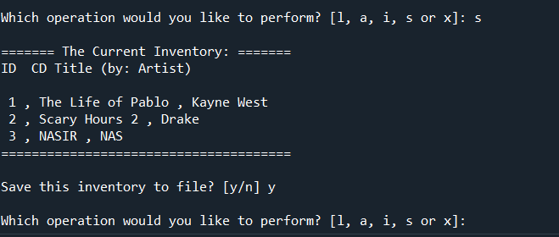

Figure IIIV

**Summary**

Using the textbook, the Module 08 documentation and videos, and the supplemental websites and video, I was able to successfully create a script that took the users input and wrote it to .txt file. Looking forward to improving on the concepts I have learned so far.